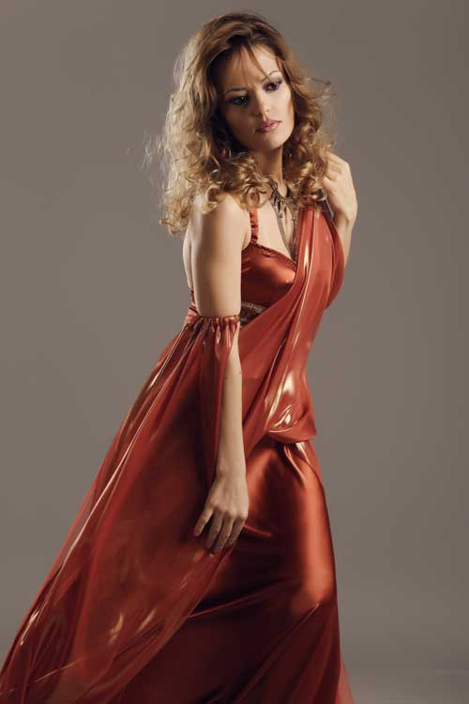**The Soprano Yenelina Arakelyan** attended The Sergey Danielyan Academy of Singing In Yerevan until 2004 and graduated in opera singing from The Komitas State Conservatory of Yerevan in 2008. At the age of 21 she played the part of Rosina in The Barber of Seville. In this same period she joined Ghazaros Saryan’s Opera Studio and took part in a study programme which included a vast repertoire of operas from Mozart to Rossini and from Verdi to Puccini. She then toured with the Armenian State Symphony Orchestra performing in a varied programme in Yerevan, Dubai and Beirut. In order to perfect her repertoire she moved to Italy in 2010 and obtained a degree in opera singing from The Ferrara Conservatory in 2014. Since then she has performed in a number of productions – namely La traviata, Aida and Un ballo in maschera – for the Florence Opera Festival in various traditional Tuscan theatres. She has also sung in concerts organised by The Frescobaldi Conservatory Ferrara in Ravenna, Ferrara and Parma. She has participated in master classes in France, Germany and Austria by maestri such as Jean Pierre Blivet, Peter Schreier and Sona Ghazarian. Her interpretative and vocal range together with her fluency in five languages enables her to take on a wide operatic repertoire and in particular the great soprano roles of Verdi due to her sensitivity, temperament and distinctive timbral traits.

*Updated to Jan 2022*